How to Open Reagent Bottles
In the chemistry lab solutions are routinely stored in reagent bottles. The bottles you will be using in the Qualitative Lab will be glass reagent bottles. There are three types of stoppers these bottles can have; flat, barrel-shaped, and penny-head. In keep from contaminating the solutions, the stoppers must be handled manners specific for each type of stopper.
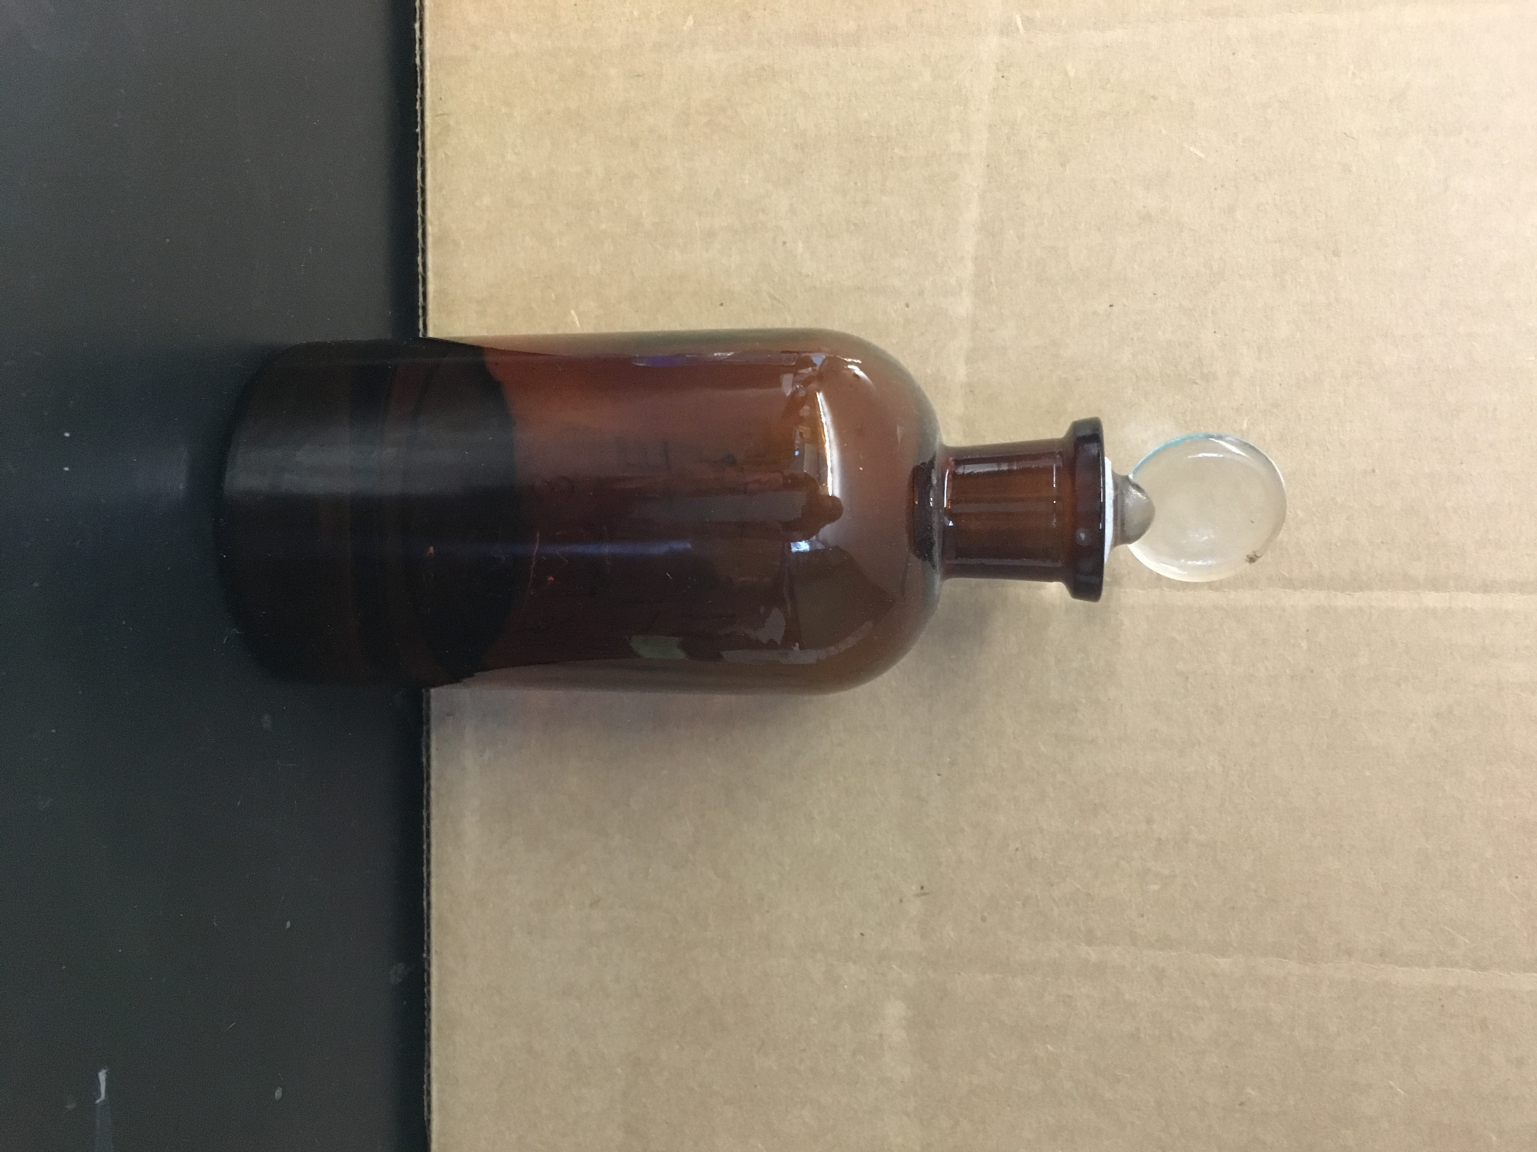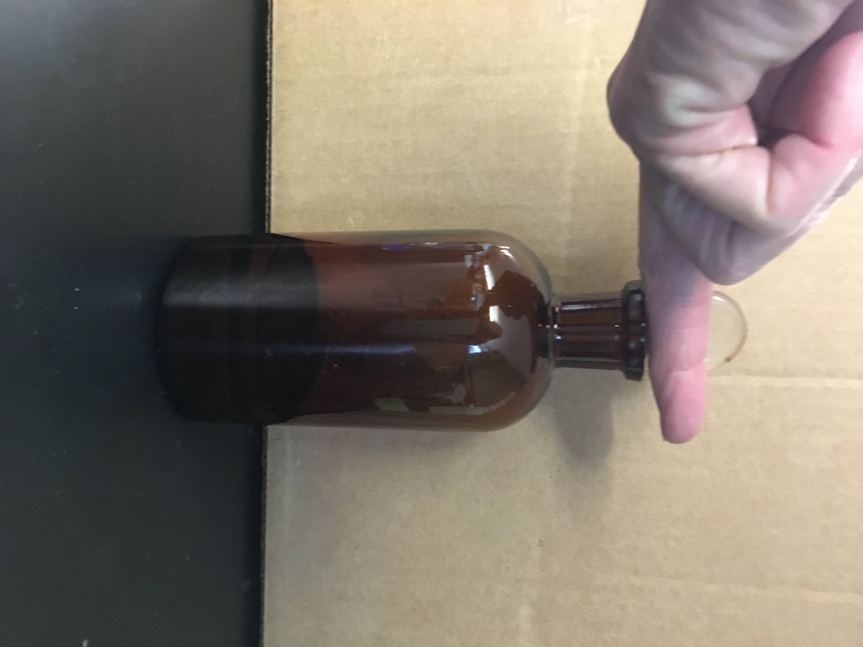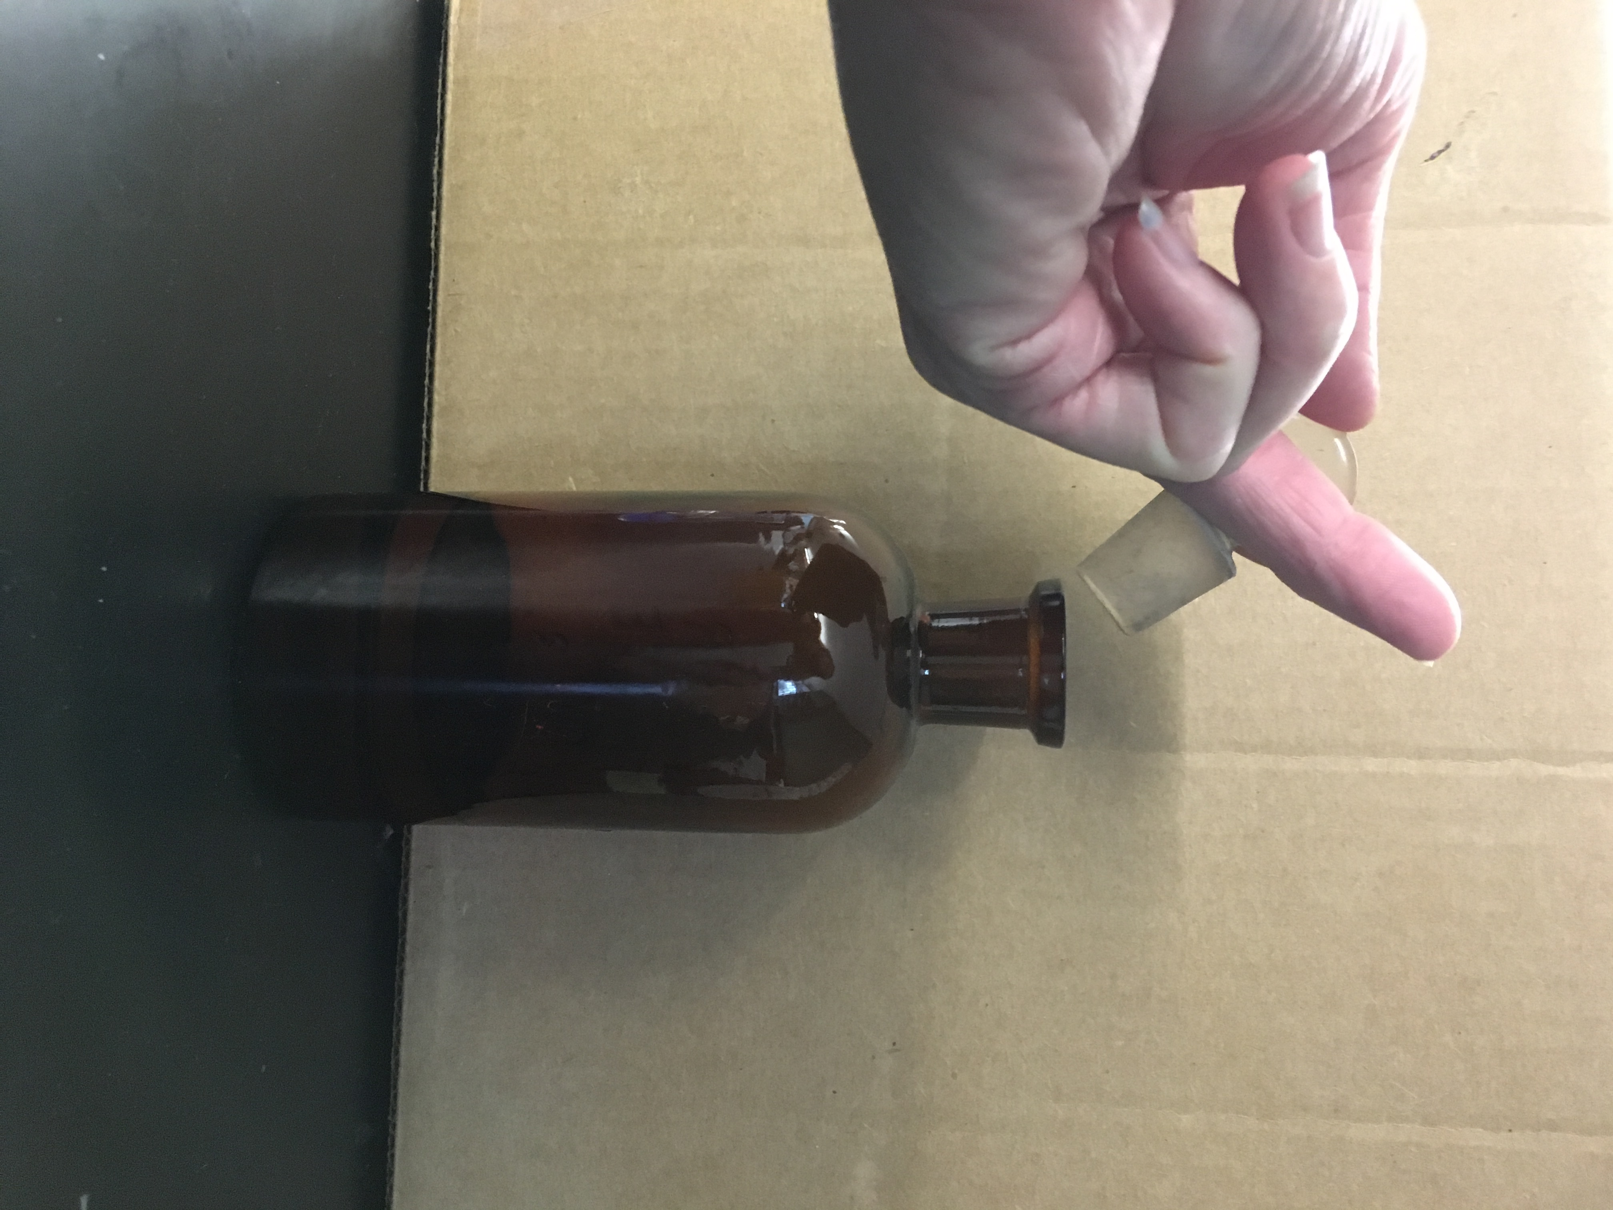
When using a bottle with a penny-head stopper, turn your hand over, grab the stopper between your first and second finger, hold the stopper this way while you removed solution from the bottle. NEVER lay the stopper on the counter.

